ROOM BOOKING FORM
Event Title:

Name of Organisation & Department:

Date(s):

Invoice to (Name and address):
Email Address: |  | Accounts Tel No:
Contact Name:
Email Address:
Phone Number:

PO Number:

Cancellation:
Please note that if you wish to cancel your booking, that you let us know at least 48 hours before your scheduled booking, otherwise a cancellation fee will apply.
By signing this form you agree to abide by this cancellation policy.

Signed: |  | Date:

Room Requirements
Please see the following pages for details on the rooms we have available and the possible layouts and delegate numbers.
Café layout
Classroom layout
Boardroom layout
U-shaped layout
Theatre - Chairs only
Café
You can also have the U-shaped layout as chairs only, please specify whether you would like tables, or chairs only.

Room: | Layout (i.e. boardroom, U-Shaped etc): | No of Delegates: | Start Time: | Finish Time:
David Baker
Sue McMullen
Dawn James
Woodward
Lodge Room
3.6 Boardroom | N/A seats up to 15

Would you like use of a projector? (David Baker, Sue McMullen and Dawn James have ceiling mounted projectors, all other rooms are portable)
Yes: ☐ No: ☐

Refreshments
Our in-house Café is run by PROPS. PROPS supports adults with disabilities to gain work experience and work opportunities. Any Teas/Coffees and Lunch or Cake can be ordered prior to the meeting or on the day in Café. To order or questions please contact Lara at catering@propsbristol.co.uk
If anyone is ordering food on the day from PROPS Café they will need to pre-order it with them before 11:00am as lunchtimes can get busy.

Please return your completed form to: office@vassallcentre.org.uk. If you have any further enquiries, please contact us on: office@vassallcentre.org.uk or call us on 0117 965 8630.

Our rooms:

David Baker
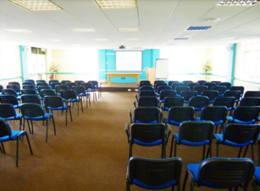
Located in Spur 5, the David Baker room is a large room which has a projector and hearing loop. The delegate layout and numbers are as follows:

- Theatre – 100 people
- Café – 60 people
- Classroom – 50 people
- Banquet – 40 people
- Boardroom – 38 people
- U-shaped/circle chairs only – 36 people
- U-Shaped tables and chairs – 28 people
Prices:
- Half day: £145
- Full day: £220

Sue McMullen
Located in Spur 9, this room is slightly smaller than the David Baker and also has a projector and hearing loop. The delegate layout and numbers are as follows:
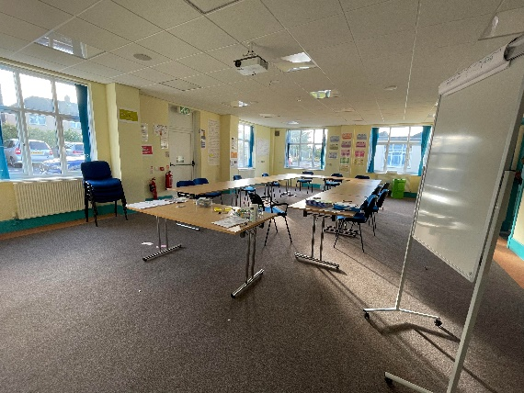
- Theatre – 50 people
- Café – 24 people
- Classroom – 30 people
- Banquet – 30 people
- Boardroom – 24 people
- U-shaped/circle chairs only – 20 people
- U-Shaped tables and chairs – 22 people
Prices:
- Half day: £111
- Full day: £192

Dawn James
Located in Spur 7, Dawn James is the same size as Sue McMullen. It has a projector and a portable hearing loop is available on request. The delegate layout and numbers are as follows:
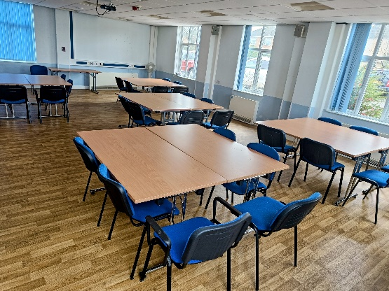
- Theatre – 50 people
- Café – 24 people
- Classroom – 30 people
- Banquet – 30 people
- Boardroom – 24 people
- U-shaped/circle chairs only – 20 people
- U-Shaped tables and chairs – 22 people
Prices:
- Half day: £111
- Full day: £192

3.6 Boardroom
Located in Spur 3, the Boardroom is set up for up to 15 delegates. There is a TV that a laptop can be connected to and a Meeting Owl is available on requests to facilitate hybrid meetings. The delegate layout and numbers are as follows:
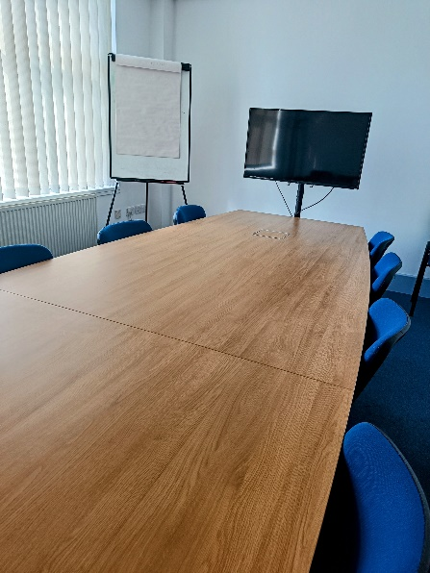
- Boardroom – 15 people
Prices:
- Hourly rate: £20p/h or:
- Half day: £70
- Full day: £145

Woodward Room
Located in Spur 9, the Woodward room is one of the smaller rooms we offer. The delegate layout and numbers are as follows:
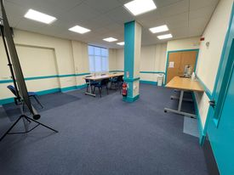
- Theatre – 16 people
- Classroom – 12 people
- Café – 12 people
- U-shaped/circle chairs only – 12 people
- Boardroom – 10 people
- Banquet – 10 people
- U-shaped table and chairs – 8 people
Prices:
- Hourly rate: £20p/h or:
- Half day: £70
- Full day: £145

Lodge Room
Located in the main corridor, the Lodge Room is the smallest room we offer, it is suitable for small meetings. The delegate layout and numbers are as follows:
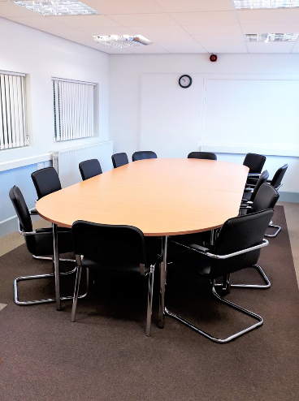
- Boardroom – 8 people
Prices:
- Hourly rate: £16p/h or:
- Half day: £65
- Full day: £120

